Requirements/Design Specification

**Capture Rate Restriction**

Revision History

|  |  |  |  |
| --- | --- | --- | --- |
| **Date** | **Revision** | **Description** | **Author** |
| 10/09/2014 | 1.0 | Initial Version with Requirements | Roger Behm |
| 10/21/2014 | 1.1 | Updated requirments based on 10/17 meeting | Roger Behm |
|  |  |  |  |
|  |  |  |  |
|  |  |  |  |

The information furnished herein by Republic Services Inc. is proprietary and confidential to Republic Services Inc. personnel and is not to be duplicated, published, or disclosed to any third party in whole or in part without permission from Republic Services, Inc.

© Copyright 2012, Republic Services Inc. - All rights reserved.

Table of contents

1 Business Requirements 6

1.1 Purpose of the Design Specification 6

1.1.1 Business Functional Requirements / Configuration 6

1.1.2 Technical Design Requirements 7

2 Assumptions 7

3 Technical Design 8

3.1 Referenced Documents 8

3.2 Process Flow and Mock Ups 8

3.3 Functional Logic 9

3.4 Data Sources & Mapping 9

3.5 InfoPro Interface 9

4 Report Changes 10

5 Appendix 10

# Business Requirements

## Purpose of the Design Specification

This document highlights items to be implemented for Rate Restriction functionality. In order to get certain functionality to the users quicker, not all items will be implemented in this first iteration.

### Business Functional Requirements / Configuration

| **Business Functional Requirement** | **Notes** |
| --- | --- |
| Config Page and/or Config Templates | No Changes |
| Commerce:  Display Rate Restriction Checkbox  (partially compelted) | Display for all terms greater than 12 months. This should filter out all Temp since all Temp are MTM. Seasonal Accounts are allowed to have Rate Restrictions. |
| Commerce:  If term selected is over 12 months, then number of boxes that appear correlate to term (completed) | * 12 month term – Rate Restriction not shown * 24 month term – “After year one” box appears only * 36 month term – “After year one” and “After year two”  boxes appear * 48 month term -  “After year one”, “After year two” and “After year three” boxes appear * 60 month term -  “After year one”, “After year two”, “After year three”, and “After year four” boxes appear |
| Commerce:  Box Populations (completed) | * Boxes to be populated with % PI or “CPI” * Blank box will be interpreted as no restriction in effect in that year. Only checking the “rate restricted” check box but not filling in any of the text boxes underneath, this is interpreted as a 12 month lock * If price is fixed for more than one year, rep should populate “0%” in the restriction text boxes. * NRD is defaulted to 10 months for all new business |
| Commerce:  User Help | * Add help icon next to Rate Restriction check box |
| Commerce:  Validate the values entered in the text boxes through the guardrails (Future Enhancement) | * Not Applicable to this release * If rate restriction is selected NRI will be be 10 months for both existing and new (already coded correctly) |
| Documentation   * CSA * Proposal * Sample Invoice | * Rate Restrictions will hit the Comments section of the customer and office use CSA * No changes to the Proposal or Sample Invoice |
| Approvals | No changes at this time |

### Technical Design Requirements

| **Technical Design Requirement** | **Notes** |
| --- | --- |
| Config (Select Service Offering) page | * No Changes |
| Commerce | * Most of the requirments in place. Need to display Rat Restriction checkbox for 12 month initial term selection * Verbiage for help icon - If you determine you need to restrict future price increases on this contract, select this box.  Once you select this box, optional boxes will pop up to cap the PI for each year of the contract term after the first year.  For “Rate Firm for the first year of the agreement”, check the Customer Rate Restriction box and leave the other prompts blank.  If you need to cap any specific year in the contract, type either the max PI percent or the term “CPI” in the boxes provided.  Ex, if you are quoting a rate restricted account that is Rate Firm for the first year with a Max PI of 8% in years 2 and 3, you will select the Customer Rate Restriction checkbox and type 5.00 in both boxes for the cap in year 2 and 3.  To restrict the account from receiving PIs during the initial term of the contract, select the Customer Rate Restriction checkbox and type 0.00 in the remaining boxes.” |
| Documentation   * CSA * Proposal * Sample Invoice | * Add rate restrictions to comments section of CSA * 12 month rate restriction should read “Rate Firm Until 9/2013” * 24 month rate restriction (PI %) should read:   “Rate Firm Until 9/2013”, Increase 5% 9/2013”   * 24 month rate restriction (CPI) should read:   “Rate Firm Until 9/2013”, CPI Increase 9/2013” |
| InfoPro Interfce | New XML tags will need to be consumed by the AAE process. See section 3.5 for details. |

# Assumptions

The following items are assumptionsout of scope

* Changing the guardrails based on rate restriction. This is planned for a future release.
* Approvals for Rate Restrctions will not be required at this time.

# Technical Design

## Referenced Documents

None

## Process Flow and Mock Ups

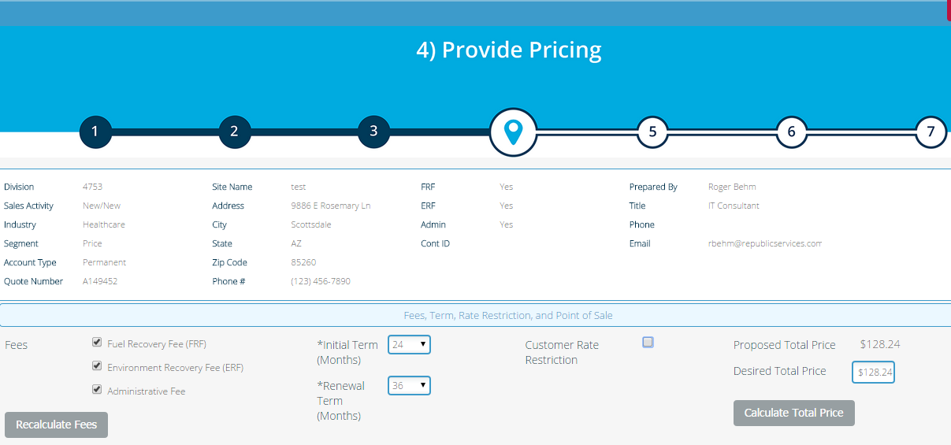

For initial terms of 24 months or greater display Rate Restriction checkbox

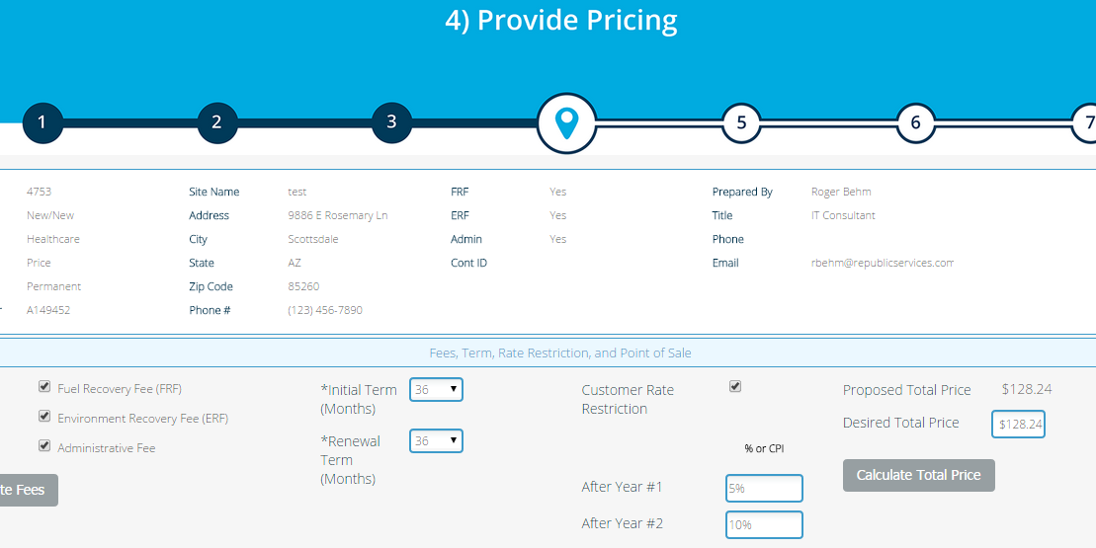

Once the Rate Restriction checkbox is checked text boxes display based on the rules in BFR-003

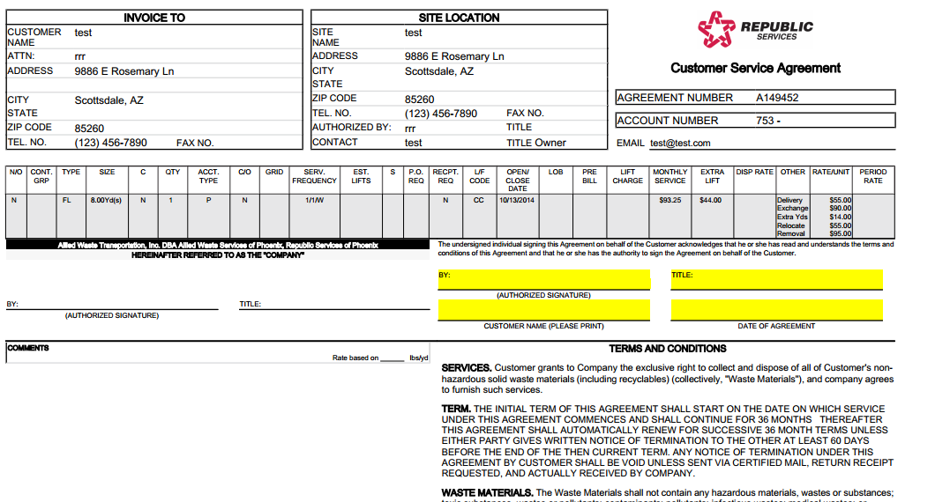

Add to comments section:

Rate Firm Until 9/2013

Increase 5% 9/2013

Increase 10% 9/2014

## Functional Logic

NA

## Data Sources & Mapping

* For detailed mapping information, please refer to the BMI [Enterprise Mapping Document](http://itpmo-2013projects/Pricing%20Initiative/2.0%20Planning%20and%20Requirements/BMI%20Enterprise%20Mapping%20Document.xlsx).
* No additional data sources or mappings needed

## InfoPro Interface

The following tags will need to be consumed by the AAE process:

<customerRateRestriction_quote>

<![CDATA[ true ]]>

</customerRateRestriction_quote>

<year4Rate_quote/>

<year1Rate_quote>

<![CDATA[ 5% ]]>

</year1Rate_quote>

<year2Rate_quote>

<![CDATA[ 10% ]]>

</year2Rate_quote>

<year3Rate_quote/>

# Report Changes

No Changes

# Appendix